BOTANY
Faculty Member:
1. Prof. Karnewar Shrikant Dharamraj
2. Prof. Burungle Sameer V.
3. Prof. Gharge Punam V.
BOTANY LAB DETAILS
Equipments
Sr no | Particular | Quantity
1 | Compound Microscope | 09
2 | Quadrats | 01
3 | Physical purity work board | 01
4 | Seed divider | 01
5 | Seed sampling trier | 01
6 | Bio visual charts | 36
7 | Hot air oven | 01
8 | Weighing balance | 02
9 | Isolation chamber | 01
10 | Visible Spectrophotometer | 01
11 | Stage micrometer slides | 04
12 | Ocular micrometer slides | 04
13 | Farmer’s potometer | 04
14 | Ganong’s Respirometer | 05
15 | Planimeter | 02
16 | Leaf Area Meter | 01
17 | Arc Auxanometer | 04
18 | Rutterner water sampler | 01

Chemicals:
Sr no | Particular | Quantity
 | Acetone | 500 ml
 | Agar agar powder | 500 gm
 | Ammonia solution | 500 ml
 | Ammonium chloride | 500 gm
 | Barium hydroxide | 500 gm
 | Boric acid | 500 gm
 | Bromophenol blue | 125 ml
 | Calcium carbonate | 250 gm
 | Calcium chloride | 500 gm
 | Calcium hydroxide | 500 gm
 | Calcium sulphate | 500 gm
 | Cobalt chloride | 100gm
 | Dimethyl sulfoxide | 500 ml
 | Eosine yellow | 25 gm
 | Erichrome Back T indicator | 25 gm
 | Ethereal | 100 ml
 | Ferric chloride | 500 gm
 | Ferrous sulfate | 250 gm
 | Gibberlic acid | 1gm
 | Glycine | 100 gm
 | Hydrochloric acid | 500 ml
 | IBA | 10 gm
 | Indol Acetic Acid | 5 gm
 | Indole acetic acid | 5 gm
 | Kaoline | 500 gm
 | Magnesium chloride | 500 gm
 | Magnesium sulphate | 500 gm
 | Malic hydrazide | 100 gm
 | Mercury pure | 250 ml
 | Methanol | 500 ml
 | Methanol | 500 ml
 | Metholic KOH | 500 ml
 | Methylene blue | 125 ml
 | NaCL | 500 gm
 | NaOH pellets | 500 gm
 | Nicotinic acid | 25 gm
 | Petrolium ether | 500 ml
 | Phenol cryst | 500 gm
 | Phenolapthalin indictor | 125 ml
 | Phenyl mercuric acetate | 100 gm
 | Polyethylene glycol | 500 ml
 | Potassium Dichromate | 500 gm
 | Potassium dihydrogen orthophosphate | 500 gm
 | Potassium hydroxide | 500 gm
 | Potassium Iodide | 250 gm
 | Potassium Nitrate | 500 gm
 | Potassium nitrate | 500 gm
 | Pydridoxin HCL | 10 gm
 | Pyrogallol | 100 gm
 | Sodium chloride | 500 gm
 | Sodium Hydroxide | 500 gm
 | Sodium molybdeate | 100 gm
 | Sodium phosphate | 500 gm
 | Sodium thiosulfate | 500 gm
 | Starch | 500 gm
 | Starch potato | 500 gm
 | Sucrose | 500 gm
 | Sucrose extra pure | 500 gm
 | Sulphuric acid | 1000 ml
 | Tetrozolium salt | 10 gm
 | Transformation kit | 01
 | Zinc Sulfate | 500 gm

Glass wares and others

Sr no | Particular | Quantity
1 | Burrette (25 ml) | 03
2 | Conical flask | 04
3 | Thread | 01
4 | Labels | 100
5 | Seed sample | 06 crops (5 kg each)
6 | Seed storage bags | 02
7 | Volumetric flask  - 10 ml  - 25 ml  - 100 ml | 06  06  02
8 | Hand sprayer | 01
9 | Forceps | 01
9 | Syringe filter | 01
10 | Spirit lamp | 01
11 | Magnifying lens | 02
12 | a)Beaker (50 ml) | 20
 | b) Beaker(100 ml) | 15
 | c) Beaker (250 ml) | 15
13 | Test tubes | 12
14 | Petri plates | 15
15 | Conical flask with side spout | 06
16 | Scissor | 01
17 | Scalpel | 01
18 | Spatula | 02
19 | Measuring cylinder (50ml, 100ml, 250ml, 1000 ml) | 06
20 | Pipette | 03
21 | Slides | 50
22 | Filter paper | 01 box
23 | Thermometer | 04
24 | Reagent bottle | 05
25 | Test tube stand | 03
26 | Mounting paper | 10
27 | Cell division slides of mitosis and meiosis | 12
28 | Towel paper | 02 box
29 | Burette Stand | 06
30 | BOD bottle | 06
31 | Pinch cock | 06
32 | Desiccators | 01

Different Practical oriented and allied activities
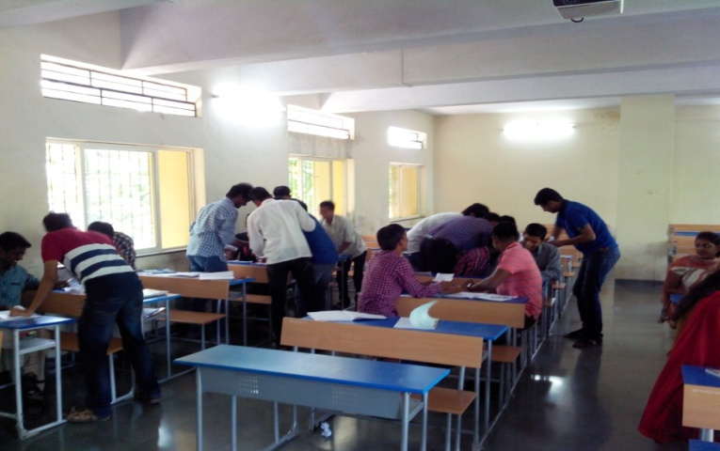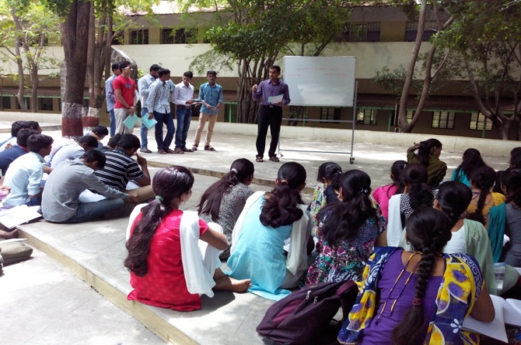
Seminars
Flipped classroom activity

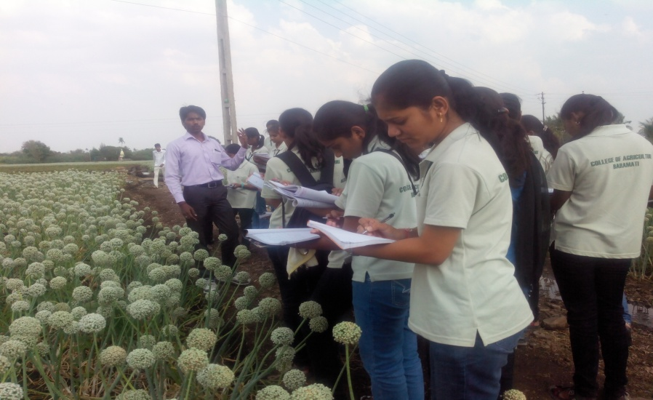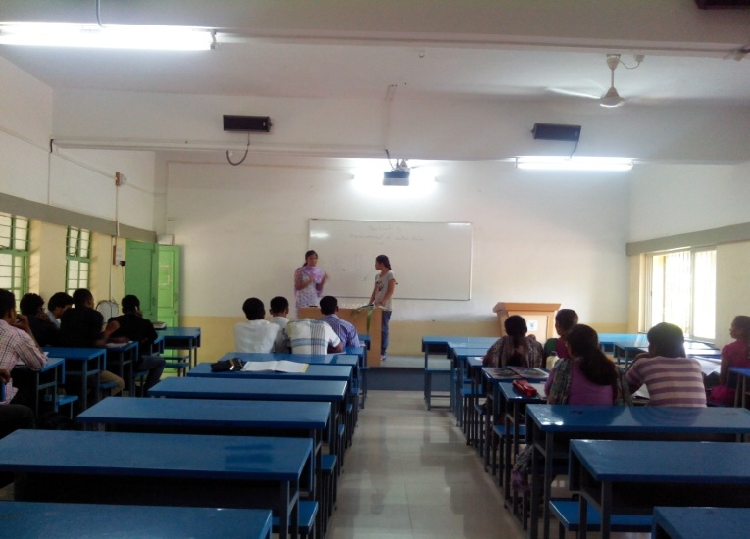
Role play
Field visit at Amar seeds pvt. Ltd. Phaltan

